Vocational School of Computer Programming and Innovations

Project Bank Deposits

Participant:

Georgi Zhechev, GTZhechev18@codingburgas.bg

Mentor: Petur Georgiev PGeorgiev@codingburgas.bg

Burgas, 2020

# Subject: Bank deposits

# Documentation

## Title / cover page

PGKPI Burgas

# Project name: Bank deposits

Georgi Zhechev GTZhechev18@codingburgas.bg

Mentor: Petur Georgiev PGeorgiev@codingburgas.bg

## Content

Contents

Vocational School of Computer Programming and Innovations 1

Project Bank Deposits 1

1 Subject: Bank deposits 2

2 Documentation 2

2.1 Title / cover page 2

3 Project name: Bank deposits 2

3.1 Content 2

3.2 Short description of our project and objectives 2

3.3 Diagram describing the menu 3

3.4 Basic functions description 4

## Short description of our project and objectives

The purpose of our project is to develop a program for managing our bank deposits. The user can enter name, family name, amount and currency of the deposit. Each depositor has a unique number generated by the system. The program allows entering deposits in three currencies: BGN, USD and EUR. Each depositor can have one deposit in each currency.

When entering a new deposit, the program requires the user to enter the depositor’s number. If such number doesn’t exist, the program returns to the main menu, otherwise it asks for the currency type. If the currency exists the system asks for amount and adds it to the deposit, otherwise it creates new deposit.

When withdrawing a deposit the program requires the user to enter the depositor’s number. If such number doesn’t exist, the program returns to the main menu, otherwise it asks for the currency type. If the user enters wrong type, the system returns to the main menu. If the currency is correct the system asks for the amount. If the amount is greater than the deposit, the system outputs a message and returns to the main menu. If the amount is less than the deposit’s amount the system withdraws the amount. If the amount equals to the deposit, the system deletes the amount.

The program also lists all the depositors and the deposits.

## Diagram describing the menu

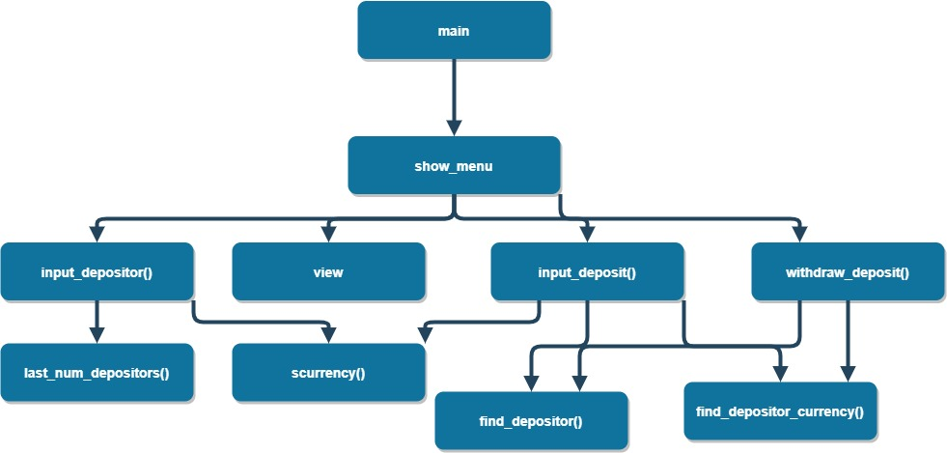

## Basic functions description

|  |  |  |  |
| --- | --- | --- | --- |
| **Name** | **Description** | **Arguments** | **Returned Value** |
| input_depositor() | Enters a new depositor. The user can enter name, family name, amount and currency of the deposit. | * Array of depositors * Array size | None |
| input_deposit() | It inputs a new deposit. When entering a new deposit, the program requires the user to enter the depositor’s number. If such number doesn’t exist, the program returns to the main menu, otherwise it asks for the currency type. If the currency exists the system asks for amount and adds it to the deposit, otherwise it creates new deposit. | Array of depositors  Array size | None |
| withdraw_deposit() | It withdraws a deposit from the current account partially or completely. When withdrawing a deposit the program requires the user to enter the depositor’s number. If such number doesn’t exist, the program returns to the main menu, otherwise it asks for the currency type. If the user enters wrong type, the system returns to the main menu. If the currency is correct the system asks for the amount. If the amount is greater than the deposit, the system outputs a message and returns to the main menu. If the amount is less than the deposit’s amount the system withdraws the amount. If the amount equals to the deposit, the system deletes the amount. | Array of depositors  Array size | None |
| view | It shows the list of all deposits and all depositors. If there is no depositors it outputs a message. | Array of depositors  Array size | None |